August 19, 2025
To Whom It May Concern,
I, Justine Tesara, authorize my mother Leni Tesara to take my graduation picture on my behalf.
Thank you.
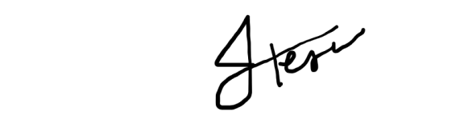
Sincerely,
Justine R. Tesara

